The Harvest at Grove Presented by Grove Bible Church  When  April 1st  4pm-7pm  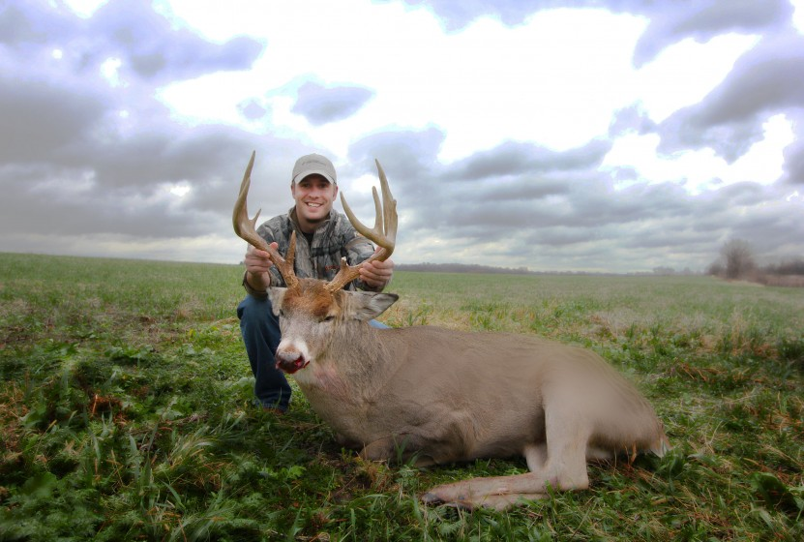  Guest Speaker: ADAM RAY  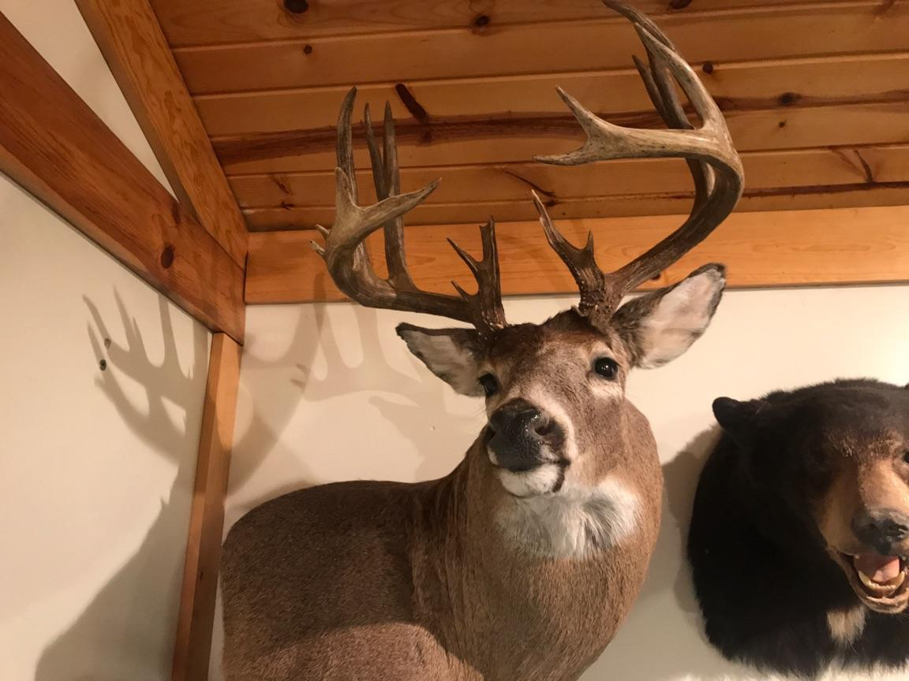  Adam lives in Lansing, Michigan and from an early age has been an avid hunter and fisherman. He has taken six Michigan deer that qualify for Pope and Young and fourteen that qualify for Commemorative Bucks of Michigan. Adam’s love for hunting, fishing and archery, has opened doors for him to speak in many venues in the mid-west about his greatest passion - Jesus Christ. Currently, Adam serves as an assistant pastor and director of "Hunting the Harvest." | Prizes Include  Crossbows, Shoulder mount, Treestands, apparel, Hunting equipment, Gift cards, and many more prizes!!!  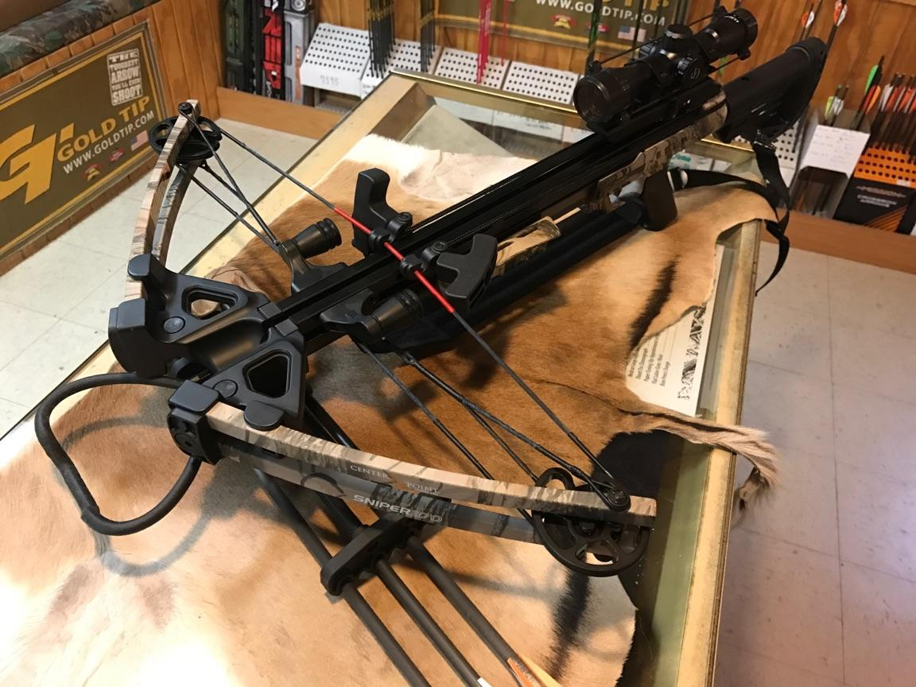  Sponsors  Country Woods Archery  Wildlife Reflections  General’s Smokehouse  Event Details  Tickets are $12. Ticket holders will have the opportunity to compete in fun and challenging competitions for prizes. Also, each ticket includes the opportunity to participate in a drawing for a couple major prizes. Ticket will include catered dinner from “General’s Smokehouse and Meats” as well as seats to hear an inspring message. The number of tickets is limited so we encourage you to get them as soon as possible.  For Tickets call  Grove Bible Church: (517)-651-5729

